

FACULTY: Information Technology
COURSE: Multivariable Calculus and Differential Equations
COURSE CODE: MATH8213
ACADEMIC YEAR: 2025 – 2026
TEAM: 1
VENUE : Gishushu Campus
LECTURER: NIZEYIMANA Viateur
SEMESTER : 1

ID | Names | Date of Meeting | Signature
26432 | Ntaganira Habimana Happy (Chief) | 17/11/2025
24122 | Mukama Yves Thomas | 17/11/2025
24673 | Kambale Kiregha Ezechiel (Sec) | 17/11/2025
24889 | Bideri Alec | 17/11/2025
25051 | Mugiraneza Mugabo Octave | 17/11/2025
25234 | Ndeko Kaduli Jordan | 17/11/2025
26233 | Jarwin W Monboe | 17/11/2025
26317 | Ishimwe Bienvenu | 17/11/2025
26439 | Niyonkuru Arnold | 17/11/2025
26505 | Shema Jean Baptist | 17/11/2025
27354 | Munyaneza Manzi Sarto | 17/11/2025
27380 | Mushirarungu Ghislaine | 17/11/2025
27388 | Bakwiye Massa Patience | 17/11/2025
27404 | Uwera Cynthia Carmella | 17/11/2025
27409 | Teta Allen | 17/11/2025
28236 | Ineza Semuhungu Joel | 17/11/2025
28240 | Rukimirana Olivier | 17/11/2025
29061 | Mutangana Joseph | 17/11/2025
26314 | Nishimwe Diane | 17/11/2025

$$MULTIVARIABLE ASSIGNEMENT \#2$$
$$I. Determine Dmf, jmf, GF$$

$$a) f\left(x,y\right)=\sqrt{\begin{matrix}25 & \begin{matrix}- & x^{2}\end{matrix} & \begin{matrix}- & y^{2}\end{matrix}\end{matrix}}$$
$$Domain x^{2}+y^{2} ≤25$$
$$JMF Minimum of f\left(x,y\right)$$
$$The square root is never negative, and it equals 0 when:25-x^{2}-y^{2}=0 {=> x}^{2}+y^{2}=25$$
$$The minimum value is 0$$
$$JMF Maximum of f\left(x,y\right)$$
$$The square root is largest when the inside is largest, i.e., when { x}^{2}+y^{2 }=0=>\left(x,y\right)=\left(0,0\right)$$
$$Then f\left(0,0\right)=\sqrt{25}=5$$
$$The maxmum value is 5$$

$$Sketch Domf(Inside/bounded) domain$$
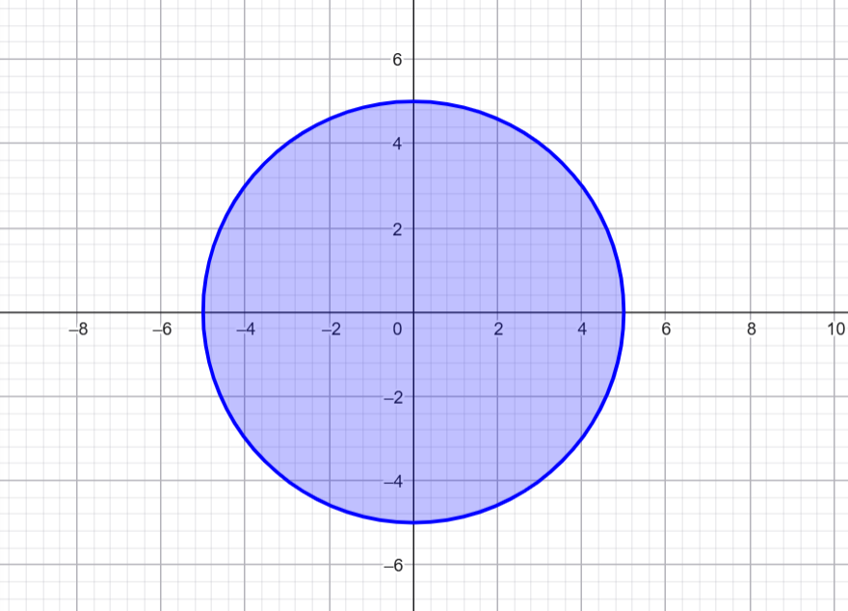
$$Sketch JMF$$
0 ------------------------- 5

$$Sketch GF$$
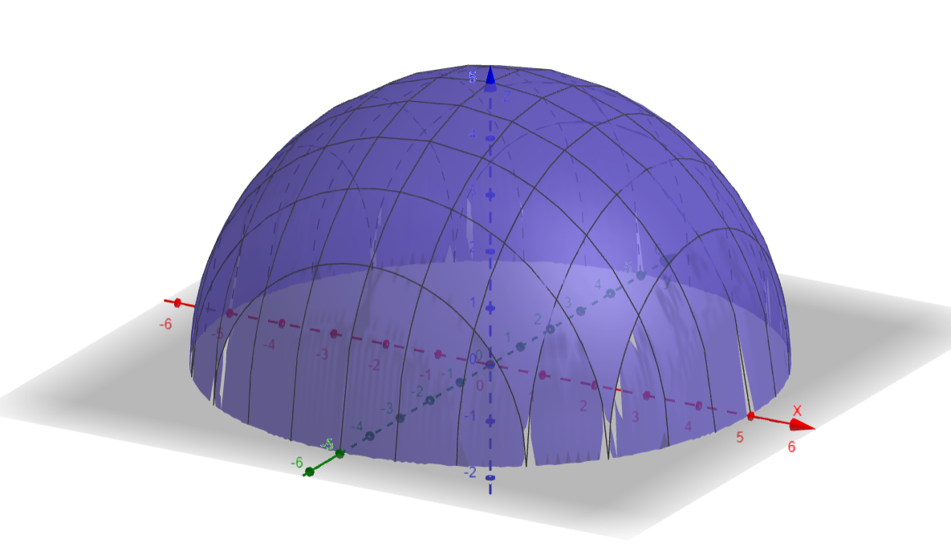
$$b) f\left(x,y\right)=\sqrt{x^{2}+y^{2}-16 }$$
$$Domain x^{2}+y^{2}≥16$$
$$JMF Minimum of f\left(x,y\right)$$
$$The radicand is zero when: x^{2}+y^{2}=16$$
$$The minimum value is 0$$
$$JMF Maximum of f\left(x,y\right)$$
$$As { x}^{2}+y^{2 }=>∞=>f\left(x,y\right)=\sqrt{x^{2}+y^{2}-16 }=>∞$$
$$There is no maxmum value$$

$$Sketch Domf(unbounded/Outside domain)$$
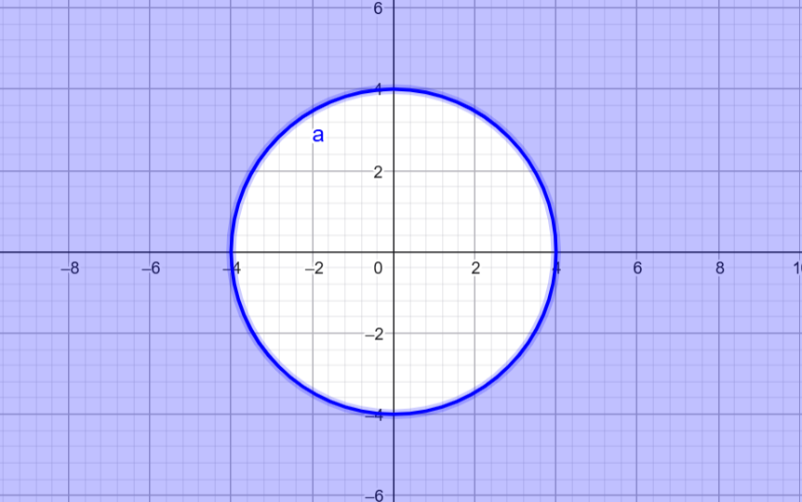

$$Sketch JMF$$
0------------------------------------$∞$
$$Sketch GF$$

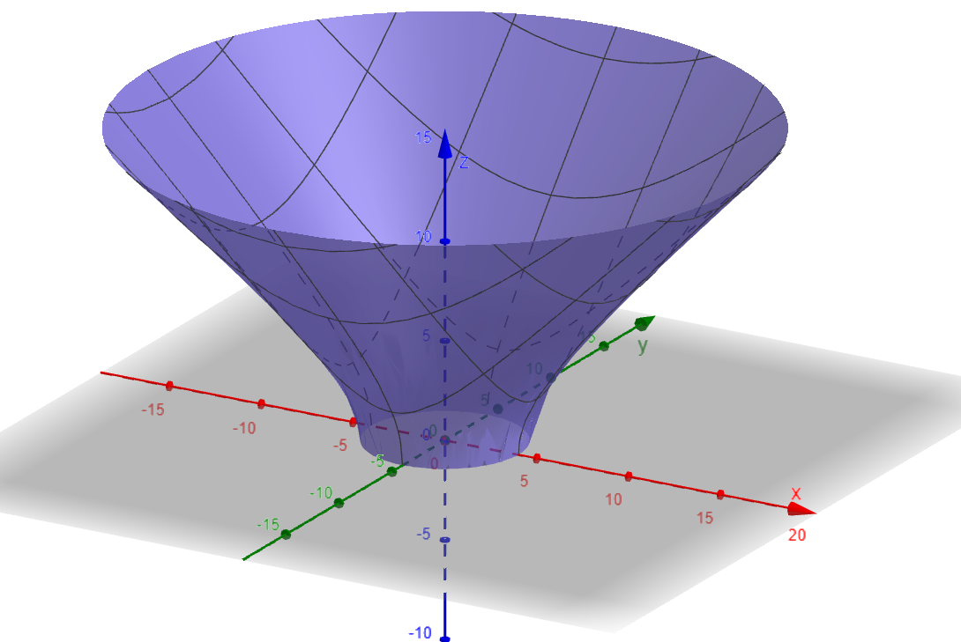
$$c) f\left(x,y\right)=ln\left(\frac{x}{y}\right)$$
$$Domain$$
$$\frac{x}{y}>0<=>xy>0$$
$$\{(x,y):xy>0,x≠0,y≠0\}$$
$$JMF of ln\left(\frac{x}{y}\right)$$
$$There is no minimum$$
$$There is no maxmum value$$
$$Because it is positive domain$$

$$Sketch Domain$$
$$Sketch GF$$
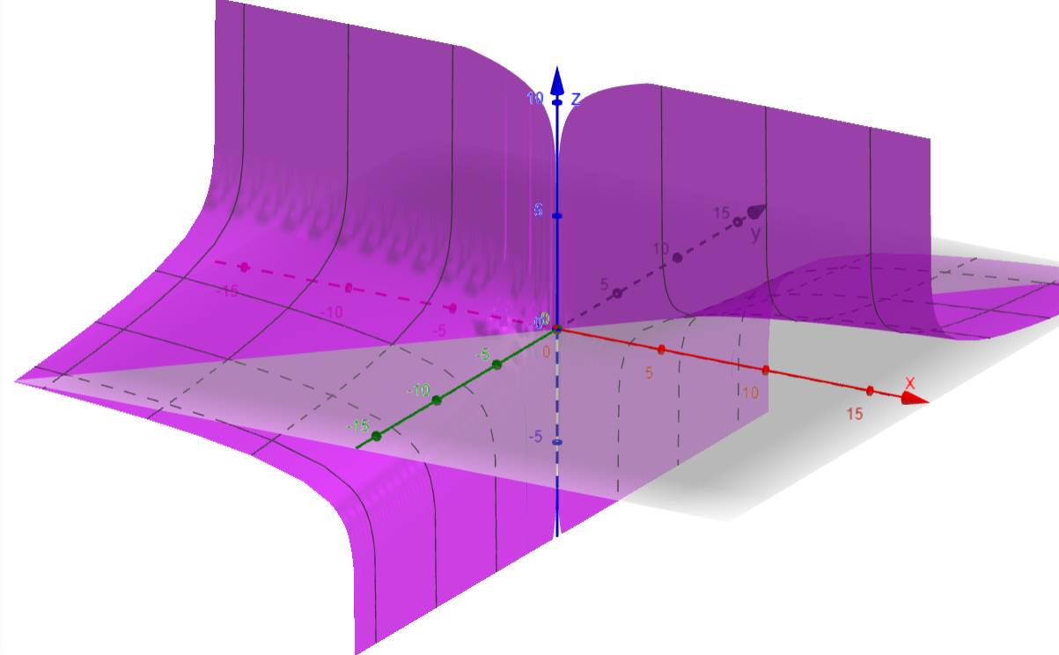
$$e) \tan^{-1}\left(x^{2}+y^{2}\right)$$
$Domain Condition 4≤x^{2}+y^{2}≤25$
$$JMF Minmum value is 4$$
$$Maxmum value is 25$$

$$Sketch domf$$
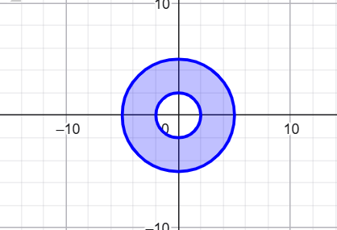
$$Sketch JMF$$
4-----------------------------25

$$Sketch GF$$
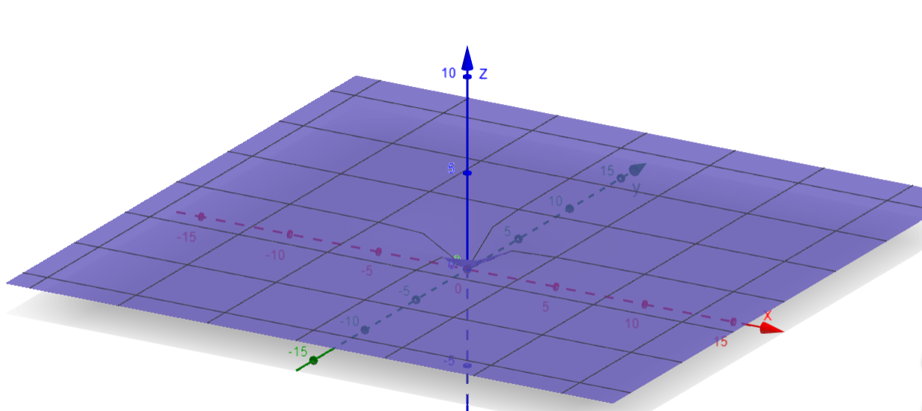

$II. Calculate the$ $d^{2}f$

$$b) y^{\sqrt{x}}$$

$$First Partial derivative with respect to x$$
$fx = f\left(x,y\right)=y^{\sqrt{x}}=e^{\sqrt{x}\ln{y}}$
$$Fx =\frac{d}{dx}\left(e^{\sqrt{x}\ln{y}} \right)= e^{\sqrt{x}\ln{y}} .\frac{d}{dx}\left(\sqrt{x }lny\right)$$
$$\frac{d}{dx}\left(\sqrt{x }lny\right)=\frac{1}{2\sqrt{x}}lny$$

$$fx=\frac{lny}{2\sqrt{x}} . y^{\sqrt{x}}$$

$$First Partial derivative with respect to y$$

$$fy =\frac{d}{dy} \left(y^{\sqrt{x}} \right)= \sqrt{x }y^{\sqrt{x-1}}$$
$$Second Partial derivative with respect to x$$
$$fx=\frac{lny}{2\sqrt{x}} . y^{\sqrt{x}}$$
$$fxx=\frac{d}{dx} \left(\frac{lny}{2\sqrt{x}} . y^{\sqrt{x }} \right)$$

$$Let U= \frac{1}{2\sqrt{x}}, V=y^{\sqrt{x }}$$
U’ = $\frac{d}{dx}\frac{1}{2\sqrt{x}}=-\frac{1}{{4x}^{\frac{3}{2}}}$
V’ = $\frac{d}{dx}y^{\sqrt{x }}=\frac{lny}{2\sqrt{x}} . y^{\sqrt{x }}$

$$fxx = (lny) \left(-\frac{1}{{4x}^{\frac{3}{2}}} y^{\sqrt{x }}+\frac{1}{2\sqrt{x}}.\frac{lny}{2\sqrt{x}} . y^{\sqrt{x }}\right)$$
1. $fxx = \left(lny \right)y^{\sqrt{x }}\left(-\frac{1}{{4x}^{\frac{3}{2}}}+\frac{lny}{4x} \right)$
$$fxx = y^{\sqrt{x }}(lny)\left(\frac{lny}{4x}-\frac{1}{{4x}^{\frac{3}{2}}}\right)$$

$$Second Partial derivative with respect to y$$
$$fx=\frac{lny}{2\sqrt{x}} . y^{\sqrt{x}}$$
$$2. fxy=\frac{d}{dy} \left(\frac{lny}{2\sqrt{x}} . y^{\sqrt{x }} \right)$$
$$\frac{d}{dy}=\left(lny.y^{\sqrt{x }}\right)=\frac{1}{y}y^{\sqrt{x }}+lny. {\sqrt{xy}}^{\sqrt{x-1}}$$
$$Fxy =\frac{1}{2\sqrt{x}}\left(y^{\sqrt{x-1 }}+\sqrt{x} lnyy^{\sqrt{x-1 }}\right)$$
$$Fxy =\frac{1}{2\sqrt{x}}\left(y^{\sqrt{x-1 }}(1+\sqrt{x} lny)\right)$$
$$Fxy = \frac{y^{\sqrt{x-1 }}}{2 \sqrt{x}} (1+\sqrt{x} lny)$$
$$3.fyy$$
$$fy =\sqrt{x }y^{\sqrt{x-1}}$$

$$fyy = \sqrt{x }\left(\sqrt{x }-1\right)y^{\sqrt{x-2 }}=(\sqrt{x }\left(\sqrt{x }-1\right))y^{\sqrt{x-2 }}$$

$C) f(x,y) =x^{\frac{1}{y}}$
$$First partial derivative with respect to x$$

$$fx =\frac{1}{y}$$
$$First partial derivative with respect to y$$
$$fy=\frac{d}{dy} ({xy}^{-1})$$
$$fy= -\frac{x}{y^{2}}$$
$$Second partial derivative$$

1. $fxx$
$$Second partial derivative with respect to x$$
$$fx^{'} =\frac{1}{y}$$
$$fx''=0$$
$$2.fxy$$
$$differentiate fx with respect to y$$
$$fxy=\frac{d}{dy}(-\frac{1}{y^{2}}$$
$3.fyx$
$$defferrentiate fy with respect to x$$
$$fy= -\frac{x}{y^{2}}$$
$$fyx = -\frac{1}{y^{2}}$$
$$4.fyy$$
$$defferrentiate fy with respect to y$$
$$fy={-xy}^{-2}$$
$$fyy= -x(-2)y^{-3}$$
$$fyy=\frac{2x}{y^{-3}}$$

$$III. Calculate the \frac{∂^{2}f}{∂r∂θ}, \frac{∂^{2}f}{∂θ∂r}, \frac{∂^{2}f}{r^{2}}, \frac{∂^{2}f}{θ^{2}}$$

$$Question b f\left(x,y\right)=x^{2}+y^{2}-\frac{2y}{\sqrt{x^{2}+y^{2}}}$$
$$1. Convert to polar coordinates$$
$$y=rcosθ, y=rsin θ, x^{2}+y^{2}= r^{2}$$
$f\left(r,θ\right){=r}^{2}-\frac{2\left(rsin θ\right)}{r} {=>r}^{2}-2\sin{θ}$
$$2. First partial delivative$$
a. $\frac{∂^{ }f}{∂r}$ = $f\left(r\right){=2r}^{ }$
b. $\frac{∂^{ }f}{∂θ}$ = $f\left(θ\right)=-2cosθ$
$$3. Second partial delivative$$
$$a. Mixed derivative \frac{∂^{2}f}{∂r∂θ}$$
$f\left(r,θ\right)$ $\frac{∂^{ }f}{∂θ}$(fr) =$\frac{∂^{ }f}{∂θ}\left(2r\right)=0$
$$b. Mixed derivative \frac{∂^{2}f}{∂θ∂r}$$

$f\left(θ,r\right)$=$\frac{∂^{ }f}{∂r}\left(fθ\right)=\left(-2cosθ\right)=0$
$$c. Second partial delivative with respect to r$$
$$frr=\frac{∂^{ }}{∂r}\left(fr\right)= \frac{∂^{ }}{∂r}\left(2r\right)=2$$
$$c. Second partial delivative with respect to θ$$
$$fθθ=\frac{∂^{ }}{∂θ}fθ= \frac{∂^{ }}{∂θ}\left(-2cosθ\right)=2sinθ$$

$$Question C$$
$$f\left(x,y\right)= x^{2}+y^{2}-2\sqrt{x^{2}+y^{2}}$$
$$1. Convert to polar coordinates$$
$$y=rcosθ, y=rsin θ, x^{2}+y^{2}= r^{2}$$
$$f\left(r,θ\right){=r}^{2}-2r$$
$$2. First partial delivative$$
a. $\frac{∂^{ }f}{∂r}$ = $f\left(r\right){=2r-2}^{ }$
b. $\frac{∂^{ }f}{∂θ}$ = $f\left(θ\right)=0$
$$3. Second partial delivative$$
$$a. Mixed derivative \frac{∂^{2}f}{∂r∂θ}$$
$frθ$ $=\frac{∂^{ }}{∂θ}$(fr) =$\frac{∂^{ }}{∂θ}\left(2r-2\right)=0$
$$b. Mixed derivative \frac{∂^{2}f}{∂θ∂r}$$

$f(θ,r)$=$\frac{∂^{ }}{∂r}\left(fθ\right)=\left(0\right)=0$
$$c. Second partial delivative with respect to r$$
$$frr=\frac{∂^{ }}{∂r}\left(fr\right)= \frac{∂^{ }}{∂r}\left(2r-2\right)=2$$
$$d. Second partial delivative with respect to θ$$
$$fθθ=\frac{∂^{ }}{∂θ}fθ= \frac{∂^{ }}{∂θ}\left(0\right)=0$$

